Artificial Intelligence (Lab)

Lab 3

Submitted to:
Sir. Rasikh Ali

Submitted by:
Name | Section | Roll Number
Nawal Rashid | BSSE-4A | SU92-BSSEM-S25-033

Contents
Task 1: BFS and DFS 3
Task 2: DLS and IDDFS 4

Task 1: BFS and DFS
Graph:
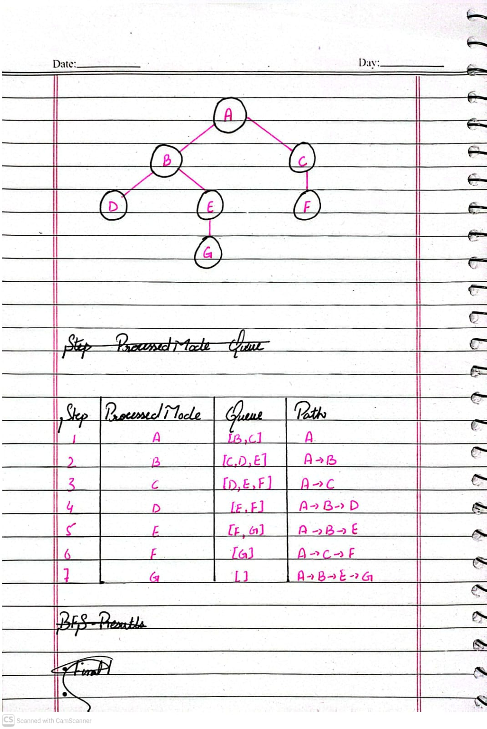
Manually Traced BFS Table:
Results:
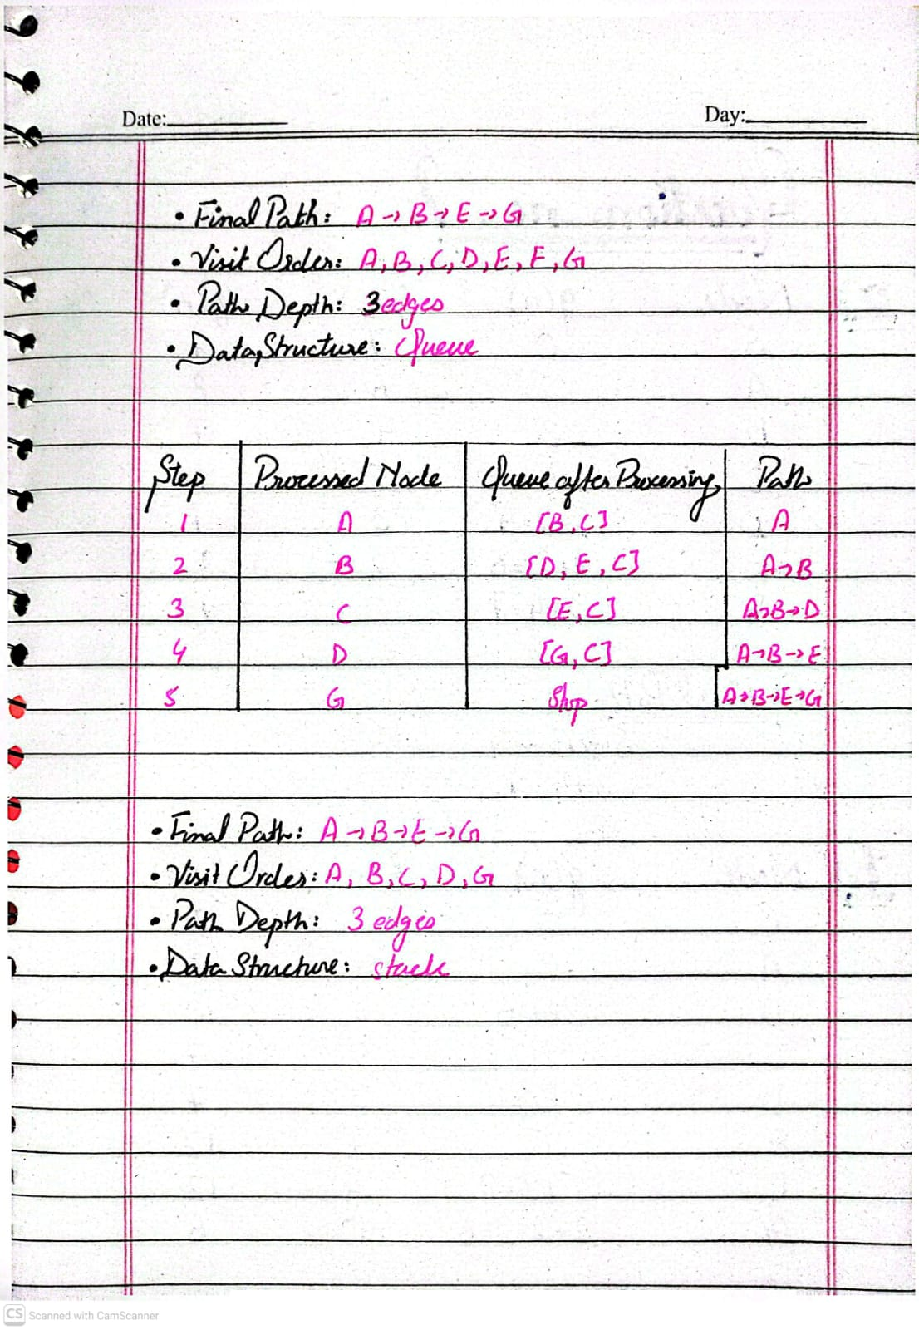

Manually Traced DFS Table:
Results:
Verification from the supplied code:
For verification I’ve run the code 3.2 BFS and DFS provided in the lab manual in my lab3_bfs_dfs.py file and it returns the following output:
['A', 'B', 'E', 'G']
['A', 'B', 'E', 'G']
This output match with the final paths obtained through manual tracing.

Task 2: DLS and IDDFS
Depth-Limited Search (DLS):
Depth Limit | Status | Path
1 | Cutoff | Not found
2 | Cutoff | Not found
3 | Found | A->B->E->G
4 | Found | A->B->E->G

Iterative Deepening Depth-First Search (IDDFS):
Max Depth | Status | Path | Limits Applied
1 | Cutoff | Not found | 1
2 | Cutoff | Not found | 1,2
3 | Found | A->B->E->G | 1,2,3
4 | Found | A->B->E->G | 1,2,3,4

Explanation:
In the graph G is at depth 3, so limits 1 and 2 cannot reach it. That’s why limits below 3 do not succeed because the goal node G is at depth 3 this is why the search cannot reach it with a smaller limit.

